Reading for pleasure
How you can help your child

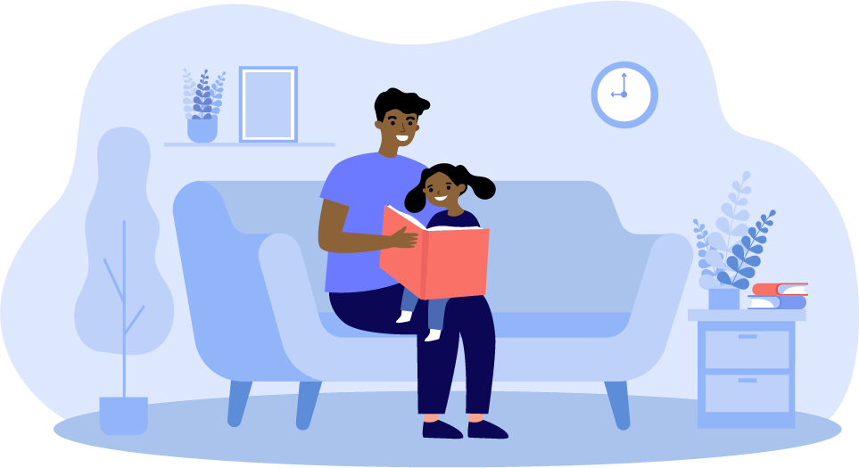

“Reading is like joy: you can exist without it, but why would you want to?”
MARCUS SEDGWICK

The Benefits of Reading
Research shows that reading has benefits in many areas of education and life. In addition to the obvious benefits on reading comprehension and attainment, it also impacts upon:

- Vocabulary

- Understanding of grammar
- Spelling skill
- Writing attainment
- Attitudes to reading and writing
- Knowledge and understanding of the world and other people
- Achievement in other subjects, including maths
- Empathy and understanding of emotions
- Development of our sense of ‘self’ and identity

Let’s take a closer look at some of these benefits:
Reading supports achievement in other subjects because it helps students to access the wider curriculum. Even maths attainment has been proven to benefit from reading skill because, in order to use maths skills, students are required to read and understand the questions they are faced with.
‘Reading is the heart of education. The knowledge of almost every subject in school flows from reading.’ Cyndi Giorgis
Research shows that reading can help to reduce stress and improve mental wellbeing. Linked to this, we know that research shows the numerous benefits of a good night’s sleep, which can be significantly helped by a reduction in screen-time. Therefore, a bedtime routine which includes reading could help with relaxing before bed.
“Because reading is so integrated into every aspect of modern life, teaching reading really is equipping children for the future.”
James Murphy
‘Excellence in almost any academic subject requires strong reading.’ Doug Lemov

Understanding students who struggle with reading
If students struggle to read, then the texts they encounter at secondary school can be off-putting for them and then, understandably, result in low levels of enjoyment and therefore demotivation. This creates a vicious cycle: as they struggle and don’t enjoy it, they read less – and because they read less, they don’t progress and then find that they struggle to acquire the necessary knowledge in many other subjects too. Wellbeing and behaviour can also be affected as a result of this.
It is, therefore, vital that we help them not just with their reading skill, but their perception of it as an enjoyable activity. Research suggests that reading for pleasure makes the most difference to students’ progress and attainment in reading. This applies to specific skills, as well as overall attainment in reading – for example, comprehension, vocabulary and grammar.

The ‘Cycle of Positive Influence’
National Literacy Trust research into the interrelationships between reading enjoyment, attitudes, behaviour and attainment suggests that the current thinking could be considered as a ‘cycle of positive influence’.
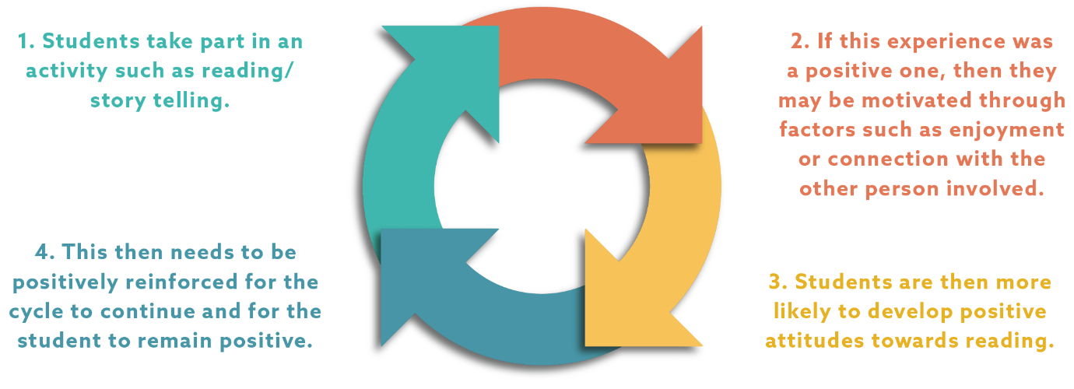

How can you support your child’s reading at home?
- Sharing your experiences about why reading is important for life and work, whilst being mindful not to add to any negative feelings, can help children to see that everyone struggles with certain things but it’s worth persevering.
- Avoid reading being seen as a chore through requests such as ‘if you read for 15 minutes, you can…’. Whilst this may work for some young people, it is unlikely to lead to reading being seen as an enjoyable activity.
- Research by the National Literacy Trust showed that reading for pleasure increased during the 2020-2021 lockdowns; one of the reasons young people gave for this was having the time to read and having fewer distractions. This would suggest that helping your child to balance their time and factor reading into their schedule in a quiet environment would be beneficial.
- Help your child to be proactive in their wider reading. For example, if they are covering World War II, explore age-appropriate texts on this through poetry, online articles or novels.
- Take an interest in what they’re reading and studying at school by reading around topics as well so that you can engage in discussion about their texts/areas of learning, whilst modelling an interest in reading.
- Help your child to experience feeling successful with reading. Praise and encourage them, whilst showing interest in what they’ve read.
- Support your child with selecting age-appropriate texts for them to read for pleasure, rather than only encouraging them to read for schoolwork. You may wish to use the PiXL half-termly newsletters to see a wide selection of books, which your school will receive.
- Often younger children enjoy reading with their parents and their interest wanes when it becomes an independent activity and they no longer share a connection with someone over a book. Read with them or listen to audiobooks, if you don’t feel confident enough to read yourself.
“By sharing books, we can help our teens find their way in this crazy, mixed-up world.” Sarah Mackenzie

Finding texts for your child
If your child struggles with reading, they may find it difficult to access certain texts that would otherwise interest them and which explore issues relevant to their age. This can be a barrier to finding reading enjoyable.
Research by the National Literacy Trust found that students who experienced an increased enjoyment in reading during Covid-19 lockdowns noted an increase in the choice of good-quality reading material as one of the reasons. However, some missed having the guidance of hearing others read and getting suggestions for different books.
It’s clear, therefore, that we all need to be able to help guide students towards finding a range of reading material they could be interested in, so that they can see the various options and have a selection to choose from. This could include non-fiction articles from magazines, newspapers or websites, novels, plays, or blog posts etc. It doesn’t necessarily matter what they read; the important thing is to help them get into reading in whatever form that may take. Emerging research also suggests that audiobooks may be helpful for increasing interest in reading, as well as modelling good reading fluency, so these may also be worth exploring if your child is reluctant to pick up a book.

Where to look:
- School and community libraries not only offer free access to books, but they often also have audio books and e-books that your child could borrow.
- Book shops provide a chance for your child to browse and purchase books with support from
staff, if they wish. Some book shops will have review cards with some of their top-picks too.
- Audio books can be purchased from devices such as phones, as well as on CDs or borrowed from a library.

How to choose:
- Remember that it doesn’t matter what they read: helping them to enjoy reading and find texts they want to read is the important thing. This might mean they find a book, collection of short stories or even a graphic novel, but it also might mean that they find a range of online articles, websites or magazines they enjoy reading.
- You could look at fiction books related to topics they are interested in, or encourage them to read about it online.
- If they’ve enjoyed a book before, encourage them to read another text by the same author.
- You and your child could spend some time browsing library or book shop shelves, speaking to the staff or reading book reviews online.
- If you are browsing in a shop/library/online, you could read the back of the books (blurbs) and a page from the start to help decide whether this feels like something they’d like to read more of.
- Be mindful about your child’s reading level so that they can access the vocabulary the text contains. You may wish to discuss this with your child’s teacher or hear them read, in a supportive way, before you start choosing texts. For some students who struggle with reading, books from Barrington Stoke publishers and the OUP Super Readable Rollercoasters may be worth exploring.
- Ask your child’s school to send you the PiXL Half-termly Reading Newsletters to get ideas for texts your child may find interesting.

The importance of listening to texts
Sharing stories as a family can be enjoyable for everyone. Often, parents stop reading aloud to their children when they can read; the problem with this is that many children then lose that sense of connection and the pleasure of sharing a story with someone else, leading to reading being seen as less pleasurable. Children can also listen to stories which contain much more complex vocabulary and concepts than they are capable of reading on their own. Reading aloud enables them to experience these more complex stories which may be more interesting to them than texts written for their reading level.
Reading aloud and sharing stories together can break through the normal routine of the day and can provide a much-needed pause, as well as creating a magical connection leading to conversations and inside jokes.
“Reading to our kids teaches them to think, make connections, and communicate. Reading aloud doesn’t just open windows. It flings wide the doors of opportunities…” Sarah Mackenzie

How could you introduce reading aloud in your home?
- Approach it through a ‘normal’ event. Over dinner, you could mention you’ve been reading something and would like your child’s opinion on the topic. Read the text to them whilst they eat and discuss their thoughts. Short extracts from articles about current events are a great way to start this with older children who may have gone a long time without being read to in the home.
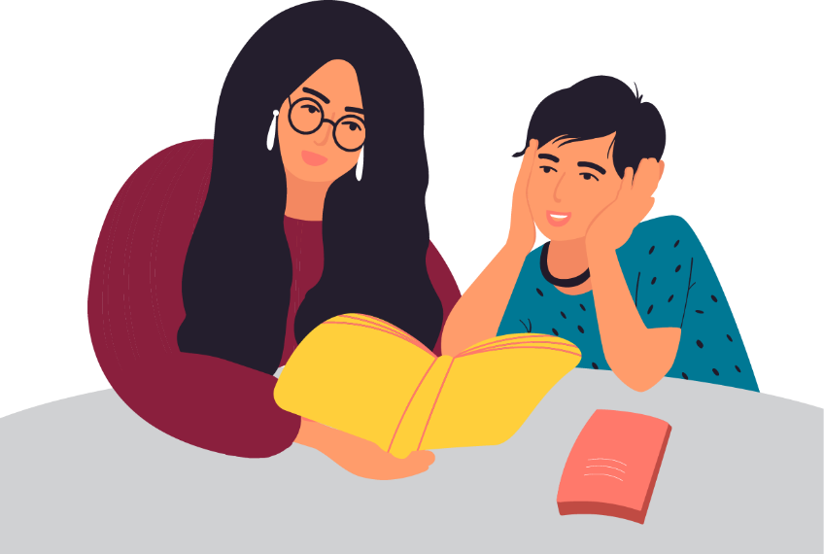
- If you are driving to school or the shops, you could put on an audiobook – the read aloud doesn’t have to be your own voice! This has benefits from families with very busy schedules, who have longer car journeys as part of their week or parents who don’t feel confident reading themselves.
- Suggest reading a novel aloud (or listening to an audio book), as a family, after dinner – they could sit drawing, painting, making models or doing the washing up.

Questions to ask whilst reading with your child
You could use the prompts below to help you start a discussion about an extract or whole text. You could read the text with your child (either one of you reading, or taking it in turns) or you could read the text independently from each other and use these prompts to start a discussion afterwards.

Before you read
Predict
Make predictions before you read something together. This could be based on what will happen next in a story, what an article could be about based on the headline or what clues the book cover can give about the narrative.

- What do you think the cover suggests about the story?
- What do you think will happen next in the story?
- What does the headline suggest the article might be about?
- What do you think you will learn/find out?

Discuss relevant knowledge and experiences
Discussing any knowledge or experience they have about a topic may help them to understand a text better or to make connections. For example, if you are reading a text about dinosaurs, you could ask what they can recall about dinosaurs, it can even be about Jurassic Park!

- What do you already know about…?
- Do you remember the time we read/watched/visited…?

During or after your reading
Check understanding regularly
As you read, you will come across words and information they may not fully understand. Make sure you pause and check your child’s understanding, thoughts or ideas about something they’ve read regularly to ensure that they definitely understand what they are reading.
- What do you think… means?
- If neither of us know what it means, how could we find out?
- What do think the writer is suggesting here?
- Which pieces of information do you think are most important and why?
- Is the writer saying … or …? Why do you think that?

Ask questions to think more deeply

Discuss why the writer has chosen to represent characters, events, settings in a certain way - don’t worry if you do not have all the answers! The important thing is to have a discussion with your child and encourage them to think about what they’ve read more deeply. Praise your child and encourage their discussion, ideas and thinking.

‘I wonder……’ questions can work well here as they leave discussion more open.

- I find your thinking behind that idea really interesting. Why do you think that?
- I wonder why the writer has chosen to use the word…? What does it make you think of/feel?
- Why do you think the writer presented the character/setting like this?
- What is the purpose of the article/speech? How can you tell?
- Why might … be important?
- How are …and … alike/different?

Summarising ideas and information
The most important step of all, summarising the ideas and information they have read, provides an opportunity to check for any misunderstandings your child may have and to consolidate their learning. Try to summarise at appropriate points throughout the text. Don’t wait until the end of the text or the chapter when they may have forgotten something.

- What are the three most important pieces of information in the text?
- What is the most interesting thing you have learnt and why?
- Which five words are key to the text and why?
- Is the tone/topic the same at the beginning and the end?
- What have you learnt?
- Were your predictions accurate? Why/why not?

Remember to restart the sequence for the next section of text.
“When we read, we can be inspired to want to build a better world
and a brighter future. So keep reading and change the world.”
Christopher Edge

© The PiXL Club Ltd. 2021. All Rights Reserved.
This resource is strictly for the use of The PiXL Club (“PiXL”) subscribing schools and their students for as long as they remain PiXL subscribers. It may NOT be copied, sold, or transferred to or by a third party or used by the school after the school subscription ceases. Until such time it may be freely used within the PiXL subscribing school by their teachers and authorised staff and any other use or sale thereof is strictly prohibited.
All opinions and contributions are those of the authors. The contents of this resource are not connected with, or endorsed by, any other company, organisation or institution.
This resource may contain third party copyright material not owned by PiXL and as such is protected by law. Any such copyright material used by PiXL is either provided under licence or pending a licence.
PiXL endeavour to trace and contact third party copyright owners. If there are any inadvertent omissions or errors in the acknowledgements or usage, this is unintended and PiXL will remedy these on written notification.

