Accessibility Plan
Manchester Vocational and
Learning Academy
19 Albert Road, Levenshulme, Manchester. M19 2EQ
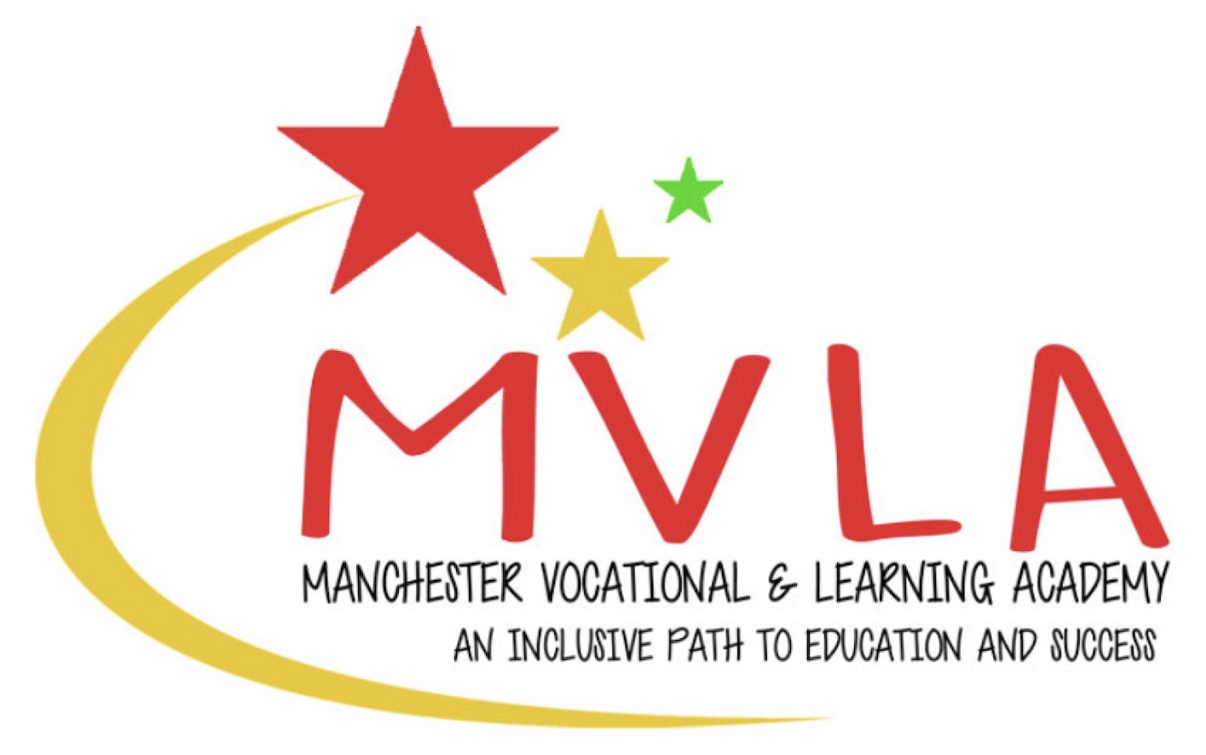

Approved by: | Mahfuza Aktar
Last reviewed on: | 1st September 2025
Next review due by: | September 2026

Contents
1. Aims 2
2. Legislation and guidance 2
3. Action plan 4
4. Monitoring arrangements 7
5. Links with other policies 7
Appendix 1: Accessibility audit 8

…………………………………………………………………………………………………………………………….

1. Aims
Schools are required under the Equality Act 2010 to have an accessibility plan. The purpose of the plan is to:
- Increase the extent to which disabled pupils can participate in the curriculum
- Improve the physical environment of the school to enable disabled pupils to take better advantage of education, benefits, facilities and services provided
- Improve the availability of accessible information to disabled pupils
Our school aims to treat all its pupils fairly and with respect. This involves providing access and opportunities for all pupils without discrimination of any kind.
We are an inclusive school and we firmly believe in equal opportunities. We strive to reinforce this through the staff we employ, our practices with young people and our professional behaviours.
The plan will be made available online on the school website, and paper copies are available upon request.
Our school is also committed to ensuring staff are trained in equality issues with reference to the Equality Act 2010, including understanding disability issues.
The school supports any available partnerships to develop and implement the plan. We work closely with the Local Authority and a wide range of partners to ensure that we meet our students’ diverse needs effectively.
Our school’s complaints procedure covers the accessibility plan. If you have any concerns relating to accessibility in school, this procedure sets out the process for raising these concerns.
We have included a range of stakeholders in the development of this accessibility plan including staff, students, parents and the Management Committee.

2. Legislation and guidance
This document meets the requirements of schedule 10 of the Equality Act 2010 and the Department for Education (DfE) guidance for schools on the Equality Act 2010.
The Equality Act 2010 defines an individual as disabled if he or she has a physical or mental impairment that has a ‘substantial’ and ‘long-term’ adverse effect on his or her ability to undertake normal day to day activities.
Under the Special Educational Needs and Disability (SEND) Code of Practice, ‘long-term’ is defined as ‘a year or more’ and ‘substantial’ is defined as ‘more than minor or trivial’. The definition includes sensory impairments such as those affecting sight or hearing, and long-term health conditions such as asthma, diabetes, epilepsy and cancer.
Schools are required to make ‘reasonable adjustments’ for pupils with disabilities under the Equality Act 2010, to alleviate any substantial disadvantage that a disabled pupil faces in comparison with non-disabled pupils. This can include, for example, the provision of an auxiliary aid or adjustments to premises.

3. Action plan
This action plan sets out the aims of our accessibility plan in accordance with the Equality Act 2010.
.

Aim | Current good practice  Include established practice and practice under development | Further actions to be taken | Person responsible | Date to complete actions by | Success criteria
Increase access to the curriculum for pupils with a disability | Our school offers an accessible curriculum for all pupils.  We use resources tailored to the needs of pupils who require support to access the curriculum.  Curriculum resources include examples of people with disabilities where available.  Curriculum progress is tracked via DC Pro for all pupils, including those with a disability.  Targets are set effectively and are appropriate for pupils with additional needs.  The curriculum is reviewed to ensure it meets the needs of all pupils. | Continue to support staff to adapt lessons appropriately, through CPD and one to one support for staff.  Continue to build on this range of resources  Continue to build on this range of resources  Provide analysis for discussion by Management Committee  Carry out relevant assessments and analysis  Discuss with Management Committee | L. Guest  M.Aktar  M.Aktar  H. Lovell  H. Lovell  L. Guest  P. Pavey | Ongoing  Ongoing  Ongoing  Ongoing  Ongoing  Ongoing | All staff report that they feel confident in addressing the needs of the current cohort of students.  Staff have a good awareness of the range of factors that might affect a student accessing the curriculum and what can be done about this.  Students have access to a wide range of resources which meet their diverse needs.  Students have access to a wide range of resources which reflect diversity.  All students have their progress tracked via DCPro and analysis takes place to identify any barriers to learning  All students have evidence based end of year/end of Y11 target in place by the end of their first half term in the school  Curriculum provision is regularly discussed and reviewed by Management Committee
Improve and maintain access to the physical environment | Where possible, the environment is adapted to the needs of pupils as required. | Explore the cost of adding ramps to improve accessibility of areas of the premises  Add a handrail to the stairs  Ensure accessibility needs are discussed during pre-admit meeting (section included on placement agreement) | M. Aktar  M. Aktar  L. Guest  M.Aktar | Ongoing  September 2025  Ongoing | More areas of the building accessible to those students with physical challenges.  As above
Improve the delivery of information to pupils with a disability | Our school uses a range of communication methods to ensure information is accessible. This includes:  - Internal signage  - Pictorial or symbolic representations  If needed, additional resources will be provided to meet the needs of individual student – for example braille of induction loops. | Ensure that the range of communication methods meets the needs of the current cohort of students – review at each pre –admission meeting | M. Aktar  L. Guest | Ongoing | All students on roll have their communication needs met by the school.

4. Monitoring arrangements
This document will be reviewed every year but may be reviewed and updated more frequently if necessary.
It will be approved by the Management Committee.

5. Links with other policies
This accessibility plan is linked to the following policies and documents:
- Risk assessment policy
- Health and safety policy
- Equality Opportunities Policy
- Special educational needs (SEN) information report

Appendix 1: Accessibility audit

Feature | Description | Actions to be taken | Person responsible | Date to complete actions by
Number of storeys | 4 floors – cellar and loft area out of bounds to students | Students currently on roll can access both floors – review arrangements if this situation changes | M. Aktar | As needed
Corridor access | Corridors reasonably wide – hard to adjust these due to nature of building | N/A | N/A | N/A
Lifts | None | N/A | N/A | N/A
Parking bays | None | N/A | N/A | N/A
Entrances | One main entrance – up several steps | When funding permits, consider adaptations that could be made to allow this to be more accessible | M. Aktar | ASAP
Ramps | No ramps currently | When funding permits, consider adaptations that could be made to allow this to be more accessible | M. Aktar | ASAP
Toilets | One on each floor – accessibility good | These are fir for purpose for students currently on roll – revisit if ramps are added. | N/A | N/A
Reception area | N/A – no reception area | N/A | N/A | N/A
Internal signage | Internal signage is clear and meets communication needs of current cohort | Keep this under review if students with additional communication needs are admitted | M. Aktar | Ongoing
Emergency escape routes | Escape routes are clearly signed and staff and students are made aware of arrangements | PEEPs to be discussed and agreed at pre- admission meetings | M. Aktar | Ongoing

