Blended Learning Policy
Manchester Vocational and Learning Academy

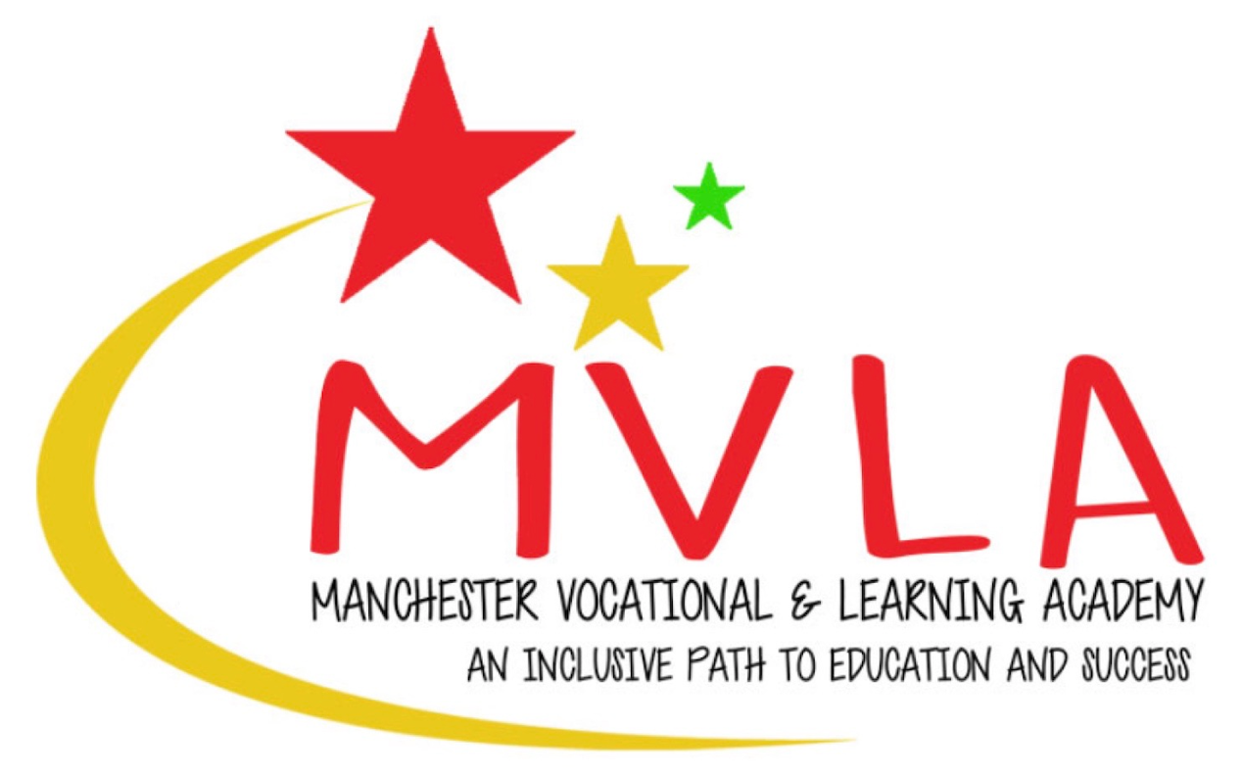

Approved by: | Linda Guest
Last reviewed on: | 1st September 2024
Next review due by: | September 2026

1.​ ​Purpose and Introduction
Background​:
The coronavirus (COVID-19) pandemic is an unprecedented challenge for our school system, and the traditional approach to delivering education. The impact of the pandemic has necessitated many pupils being out of school, and this will continue to be the case for some pupils, in line with the legal requirements and guidance in place to tackle the virus. Schools have responded to this with a strong and proactive commitment to providing remote education, in challenging and uncertain circumstances.
The intention of this Direction is to provide legal certainty for all involved in the education sector, including parents, teachers and schools themselves. It makes clear that schools have a legal duty to provide remote education for state-funded, school-age children unable to attend school due to coronavirus (COVID-19). The Department for Education is providing further support for schools so that they are able to do so.
The Direction requires that where a class, group of pupils, or individual pupils need to self-isolate, or there are local or national restrictions requiring pupils to remain at home, schools are expected to provide immediate access to remote education. The expectations on the quality of remote education expected of schools remain those set out in the guidance for full opening published in July 2020.
The Direction was issued by the Secretary of State for Education on 30 September 2020 and will come into force on 22 October 2020.
This policy is in response to this requirement.
Statement of Intent:
This policy will outline the types and methods of blended learning; provide guidance on the approach to blended learning that should be taken by staff, pupils and parents; and, aim to ensure consistency of approach across all departments in the school. Consequently, Manchester Vocational and Learning Academy will continue to provide engaging, exciting and challenging learning opportunities, both in school and at home, which result in ambitious, capable learners, committed to lifelong learning. Additionally, the well-being of pupils and staff is a significant consideration; it is recognised that learning can give a sense of purpose and achievement which is good for mental well-being. The policy aims to ensure a seamless and efficient blend of in-school and at-home learning, thus allowing pupils to make progress while staff workload remains manageable.
Definition of Blended Learning:
"At its simplest, blended learning is the ​thoughtful​ integration of classroom face-to-face learning experiences with online learning experiences." [Garrison and Kanuka, 2004]. At Manchester Vocational and Learning Academy, this means that time spent learning in the classroom will introduce key concepts, new content and skills; address misconceptions; answer questions; and, set clear expectations and guidelines for the work to be completed at home. However, it should be noted that the learning that takes place at home will take a variety of forms and will not be restricted to online provision.
2.​ ​Scope
This policy applies to all teaching, learning support and achievement staff at Manchester Vocational and Learning Academy School.
​3.​ ​Guidance
Types of Blended Learning:
A. Face-to-Face Time with Pupils
This is the most traditional form of teaching and learning. It is a ‘teacher-centred’ method of education and takes place in school, in person. Pupils benefit from increased levels of interaction with their peers, as well as with their teacher, and are allowed the opportunity to bond with fellow pupils. In face-to-face learning, students are held accountable for their progress at the specific time the lesson is taking place, for example, through the use of AfL techniques.
B. Flipped Learning
In the traditional approach to teaching and learning the teacher is the primary source of information. By contrast, the flipped learning model deliberately shifts instruction to a pupil centred approach, where ​in class time​ is dedicated to: exploring topics in greater depth; introducing complex concepts; answering questions; addressing misconceptions; setting clear expectations around work to be completed at home (online or paper based); and, creating rich learning opportunities. As a result, pupils are actively involved in knowledge construction as they participate in and evaluate their learning in a manner that is personally meaningful.
C. Online Learning
The school’s platform for sharing online resources and setting work will be Google Classroom. Pupils will also be able return/submit completed tasks through this platform. It is recognised that a considerable amount of engaging and effective work has been set through platforms such as YouTube. The continued use of these platforms is consistent with this policy and to be encouraged. ​However, for consistency (and to minimise the number of emails pupils receive) resources and links associated with the work on alternative platforms should be posted on Google Classroom instead of being emailed.
- Asynchronous Learning
Asynchronous learning is learning that doesn't necessarily happen at the same time for the teacher and the pupils. There is no real-time interaction; the learning resources are created and made available for pupils to use later on. The main features of asynchronous learning are:
- resources and activities delivered online, e.g. through Google Classroom;
- recorded lessons/video instruction/podcasts;
- flipped learning - pupils engage with material before discussions in class.
- Synchronous Learning
Synchronous learning is teaching and learning that happens where the teacher is present at the same time as the pupils, meaning that there is real-time interaction between them. The main features of synchronous learning are:
- live, streamed lessons (see information below).
The School Teachers' Terms and Conditions Document 2019, and other important legislative policies and procedures, do not currently provide a sufficiently robust framework for these types of lessons to be considered in the best interests of staff and pupils. Therefore, teachers at Manchester Vocational and Learning Academy are not expected to deliver live, streamed lessons until appropriate policy, legislation, secure technical hardware and software is available. Appropriate consultation with teachers and Trade Unions will also need to take place at a local and national level before any change to the school’s position is considered.
- live online/ telephone pastoral/achievement team check in sessions.
Hard Copy Physical Resources
Where IT equipment and internet access is a barrier to learning, students will be provided with hard copy resources. These physical copy physical resources could include:
- paper packs and work booklets;
- textbooks;
- resources needed for projects, games and activities.
These will either be posted to the student’s home address or, where safe and appropriate, dropped off by a member of staff.
4. Responsibilities
Individuals | Responsibilities
Headteacher | The role of the Headteacher is to:  - develop, monitor and evaluate the whole school strategy for blended and distance learning;  - communicate with, and provide support to, departments, staff, pupils and parents, to ensure effective implementation of blended and distance learning;  - provide opportunities for appropriate CPD training to ensure that staff are able to deliver blended and distance learning effectively;  - ensure accountability of the blended and distance learning process, through departmental self evaluation.
Teacher | The role of the teacher is to:  - continue to strive to deliver consistently excellent lessons in;  - engage with any required CPD training to ensure proficiency in delivering effective blended and distance learning;  - collaborate with colleagues to design and develop high-quality blended and distance learning experiences for pupils, in accordance with departmental plans;  - plan and deliver blended and distance learning experiences for all pupils, including those with additional learning needs, taking into account Individual Development Plans and ensuring that pupils’ needs are fully catered for;  - communicate with, and provide timely feedback to, pupils;  - carefully monitor pupils’ work completion and deadline compliance;  Teachers will not be able to respond to multiple requests for assistance. Questions can be asked at the next face-to-face session with the teacher. If unsure about what to do with a task, pupils should: read questions and instructions carefully; research the answer to the question; or, collaborate with a friend/another pupil/classmate. If, while learning at home, a pupil has a problem that cannot be solved, then this should be reported during daily welfare calls.
Pupils | Pupils should:  - record tasks set at the end of each face-to-face lesson in school, noting the due date for completion;  - dedicate appropriate time to distance learning, in order to complete the tasks set by the due date;  - check Google Classroom for information on tasks, assignments and resources daily, throughout the school week;  - identify a comfortable and quiet space to study/learn;  - engage in all learning set with academic honesty;  - submit all tasks and assignments in accordance with provided timelines and/or due dates;  - appreciate that when working at home, teachers will possibly be delivering lessons every day at school.
Parents/Carers | Parents/Carers should support their child/ren in their learning by:  - providing an environment conducive to learning;  - engaging in conversations about resources, tasks and assignments provided/posted;  - monitoring time spent engaging in online and offline learning;  - helping to provide emotional balance through ensuring ample room and time for reflection, physical activity, conversation, rest and play.

5.​ ​General Guidelines and Expectations
The Education Endowment Foundation, in its report on distance learning during school closure,​ ​highlights the following:
- Teaching quality is more important than how lessons are delivered;
- Ensuring access to technology is key, particularly for disadvantaged pupils;
- Peer interactions can provide motivation and improve learning outcomes;
- Supporting pupils to work independently can improve learning outcomes.
Therefore, it is important that everything put in place meets the four guidelines referenced above and that we have clear expectations for blended learning.
Expectations:
- Establish a Google Classroom for each group and ensure it is used in the most effective and efficient way. It is important that each group has their own Google Classroom, so that the class teacher can monitor his/her own pupils’ engagement and progress. The establishment of the Google Classroom and its effective use is the ​responsibility of the class teacher;
- Ensure that the title/label of the Google Classroom clearly identifies the ​class, subject and teacher​ so that pupils can easily identify and quickly access classrooms;
- Recognise the need for one ‘work stream’ - the work completed during face-to-face learning will complement and consolidate the work completed by pupils remotely, and vice versa;
- Consider and plan for the ‘work stream’ to be completed, anticipating likely questions and problems that pupils may encounter;
- Ensure face-to-face learning incorporates:
  - the introduction of new concepts;
  - the explanation of difficult concepts;
  - problem solving;
  - explicit teaching of new skills;
  - tasks that complement and consolidate the learning that takes place at home;
  - interactive discussion;
  - practicals (as/when appropriate);
  - the use of class time to personalise learning.
- Ensure at-home learning incorporates:
  - tasks that complement and consolidate the learning that takes place in the classroom;
  - tasks that pupils can complete to enhance learning that takes place in the classroom, for example,
  - research of/reading about a new topic to be introduced;
  - tasks that allow pupils to practise new skills learnt during face-to-face time in school;
  - note-taking, summarising and formation of questions in preparation for face-to-face time in school.

- ‘Chunk’ work that is to be completed. Masses of content should not simply be ‘dropped’ into Google Classroom with a completion date. Teachers should consider learning objectives for periods of two weeks and ensure that all tasks to be completed (both in school and at home) allow pupils to meet these objectives;
- Clearly communicate learning objectives, for each two week period of work, to pupils so that they know exactly what is expected of them and what they will be doing in school and at home;
- Make deadlines for work completion clear to pupils. Make explicit the method of how pupils can submit completed written work (e.g. during face to face lessons on paper/ books, by uploading to Google Classroom etc.);
- Provide clear instructions for how the work set can be completed. These instructions can be delivered during the face-to-face time with pupils but should also be available for pupils to access at home, either by uploading them to Google Classroom or by including them in the paper resources provided;
- Consider how videos/podcasts can be used effectively to supplement, complement, and assist with the completion of, work set.
Marking, feedback and assessment
Not all submitted written work needs to be quality marked in detail by the teacher; however, it is important that work completion is tracked so that pupils who are not engaging with the work set can be appropriately supported. It is important to remember that feedback is considered so that learning, rather than simply provision, is taking place. The nature of marking and feedback given will depend on the type of work completed and the method of submission.
Staff should consider how pupils can be formally assessed so that progress can be effectively monitored and intervention can be put in place where necessary.
Self assessment may be an integral part of a blended learning approach; however, in order for this to be effective, pupils must be able to accurately and confidently self assess their work and progress. Therefore, clear guidance and expectations relating to this will need to be provided by subject teachers.
Engagement
For a blended learning approach to be effective, it is of critical importance that all pupils engage with the process. Therefore, pupils must have a secure understanding of what they have to do and by when. Differentiation, a comprehensive overview and clear instruction will be of critical importance, to enable pupils to balance work completed in school and at home.
We expect that all pupils will engage with this approach to teaching and learning and exceptional levels of engagement can be celebrated by departments in already established ways. It needs to be made clear to pupils that work is not “optional” and we expect tasks to be completed. Clear deadlines should be set to give pupils an explicit understanding of what is required, by when.
If pupils do not engage appropriately, our normal procedures, as outlined in the School’s Behaviour Policy, will apply. However, we must recognise that pupils may be having difficulty in adapting to the new way of working or are struggling with barriers to learning, e.g. lack of space to work at home; unreliable broadband or limited ICT provision; etc. Therefore, it is important to try and establish what these barriers are and how we might help to remove them. Established lines of referral should be used as necessary. Communication with pupils in school and with parents at home will be an important way of addressing these issues.
If a pupil still fails to engage, then the usual procedures within the Behaviour Policy will be followed.
Training
To ensure that pupils can make the most of blended and distance learning, they may require training and support on:
- the effective use of Google Classroom
- how to navigate the Classroom;
- ​how to submit work;
- ​how to keep track of tasks/assignments.
To ensure that teachers can proficiently deliver blended and distance learning experiences, they may require training and support on:
- ​how to ensure the Classroom is the main source of setting and receiving work; ​
- how to organise Google Classroom and, in particular, classwork into categories;
- how to support students to photograph their work rather than upload a ‘Word’ document) within Google Classroom;
- how to create a quiz/assignment on Google forms;
- the effective use of PowerPoint including;
- creating and embedding podcasts and video clips into PowerPoint;
- use of hyperlinks to bring pupils from PowerPoint to necessary documents.
Teachers may use time not spent teaching to:
- source/create podcasts/videos relevant to SoWs for use when pupils are working at home; create prescriptive self-assessment templates for use with pupils, especially for tasks that will be completed at home that would not otherwise be teacher assessed.
​6.​ Content and Timing
Research indicates that pupils cannot be expected to replicate the school day when learning at home; therefore, it is unrealistic to expect pupils to engage in five hours of independent work per day that they are at home. However, in order to ensure that pupils gain maximum benefit from the blended learning experience, teachers should set tasks that allow for the lesson objectives to be met; the course content to be completed; and, the time spent learning in school to be as productive as possible.
7. Monitoring and review
The Headteacher will monitor and evaluate the provision of blended and distance learning through established monitoring and quality assurance procedures. This policy will be updated at least every 2 years.

