Drugs and Illegal Substances Policy

**Manchester Vocational and Learning Academy**

|  |  |  |
| --- | --- | --- |
| **Approved by:** | Linda Guest |  |
| **Last reviewed on:** | 1st September 2024 | |
| **Next review due by:** | September 2026 | |

The aim of this policy is to acknowledge and clarify the school’s role in drug prevention and education and ensure it is appropriate to pupils’ needs. The policy provides information and guidance about drug education, as well as procedures to respond to any drug-related incident, for pupils, teachers, support-staff and outside agencies or individuals.

The policy aims to ensure that the approach taken on the issue of drugs is a whole-school one and is part of our commitment to and concern for the health and well-being of the whole school community. Staff will need to be confident and skilled to teach drug education and pupils need to receive up to date, relevant and accurate information as well as support.

This policy aims to make clear procedures for responding to and managing drug-related incidents. Sanctions for incidents will be consistent with the school’s behaviour policy. This policy applies at all times to the school premises, school transport as well as school visits/trips/residentials etc.

Definition: “Drugs” are taken here to mean those that are legal, such as alcohol, tobacco and solvents, over the counter and prescribed drugs, and illegal drugs such as cannabis, ecstasy, amphetamines, heroin, crack/cocaine, LSD, Novel Psychoactive Substances (NPS) and any other substances covered by the 1971 misuse of drugs act; psychoactive substances act 2016, or that is subject to a temporary class drug order (TCDO). The school prohibits all substances having psychoactive effects on the brain: depressants, stimulants, cannabinoids, and hallucinogens.

The school believes that the possession and or use of such drugs in school, during the school day or while travelling to/from school is inappropriate. The drugs/substances covered by this policy are not to be bought, sold or otherwise exchanged or brought onto school premises during the school day, or while pupils are on school visits. Individual exceptions may be made for pupils who require prescription medicines where appropriate.

Drug Education: The school provides a planned drug education curriculum through the following:

* Key Stage 3, 11-14 year olds should be taught that abuse of alcohol, solvents, tobacco and other drugs affects health; that the body’s natural defences may be enhanced by immunisation and medicines; and how smoking affects lung structure and gas exchange
* Key Stage 4, 14-16 year olds should be taught the effects of solvents, tobacco, alcohol and other drugs on body functions

Other discretionary topics will be delivered through PSHE and outside agencies and will reflect knowledge, understanding, attitudes and social skills that will:

* + Enable pupils to make healthy, informed choices
  + Promote positive attitudes to healthy lifestyles
  + Provide accurate information about substances
  + Increase understanding about the implications and possible consequences of use and misuse
  + Widen understanding about related health and social issues
  + Enable young people to identify sources of appropriate advice and personal support

On the whole, it will be teachers and outside agencies who will teach drug education. Such agencies should be used in a planned way and their contributions evaluated.

Teachers will have access to on-going advice, support and training as part of their own professional development. The school actively cooperates with agencies such as the LA, police, health and drug agencies.

Statutory duty of the school: The head teacher takes overall responsibility for the policy and its implementation, for liaison with the Management Committee, parents/ carers, LA and appropriate outside agencies. The headteacher/Proprietor will ensure that all staff dealing with substance issues are adequately supported and trained.

A school cannot knowingly allow its premises to be used for the production or supply of any controlled drug (e.g. the preparation of, or smoking of cannabis). Where it is suspected that substances are being sold on the premises, details regarding those involved, and as much information as possible, will be passed to the police.

Please note that drug use and possession will not automatically result in exclusion. The only person with legal authority to issue an exclusion is the Headteacher. There are circumstances where exclusion is not appropriate as it could compromise the school’s duty of care to the student. The Headteacher will always make the decision about actions to take and sanctions to be issued in a drugs related incident, or where there are concerns that a student may have taken an illegal substance prior to arrival at school.

The school has adopted the procedures as laid out in Drugs: advice for schools (DFE-00001-2012

* Any medical emergencies will be dealt with as per Appendix A
* In cases of substance use/misuse or supply on the premises, during the school day or during school visits etc., the case will be discussed with the young person and a written report added to CPOMS; parents/carers will be informed by the Headteacher or Proprietor as soon as possible. The support of outside agencies will be sought if appropriate
* If a young person admits to using or supplying substances off the premises, the appropriate action will be to inform the inform the Headteacher/Proprietor, who will inform the parents/carers or delegate someone else to do so
* While there is no legal obligation to inform the police, they may also be involved at the discretion of the Headteacher/Proprietor in consultation with Management Committee members and staff who know the young person well
* The school will consider each incident individually and will employ a range of responses to deal with each incident. Specific cases will be managed as per Appendix B: all staff, pupils, parents/carers will be informed of these issues.
* The Management Committee will be involved in drug-related incidents as they are concerning other matters relating to the school.
* The Head teacher will take responsibility for liaison with the media, where required.

This policy will be reviewed by the headteacher every two years.

APPENDIX A : Drug situation – medical emergencies  
APPENDIX B : Situations involving drugs without medical authority

**Appendix A : Drug situations – medical emergencies**

The procedures for an emergency apply when a person is at immediate risk of harm. A person who is unconscious, having trouble breathing, seriously confused or disorientated or who has taken any harmful toxic substance, should be responded to as an emergency.

The main responsibility is for the pupil at immediate risk, but you also need to ensure the well- being and safety of others. Put into practice the school’s first-aid procedures. If in any doubt, call medical help.

**Always:**

* Assess the situation
* If a medical emergency, send for medical help and ambulance

**Before assistance arrives:**

If the person is conscious:

* Ask them what has happened and to identify any drug used
* Collect any drug sample and vomit for medical analysis
* Do not induce vomiting
* Do not chase or over-excite them if intoxicated from inhaling a volatile substance
* keep them under observation, warm and quiet

If the person is unconscious:

* Ensure that they can breathe and place in the recovery position
* Do not move them if a fall is likely to have led to spinal or other serious injury which may not be obvious
* Do not give them anything by mouth
* Do not attempt to make them sit or stand
* Do not leave them unattended or in charge of another pupil
* Notify parents/carers

For needle stick(sharps) injuries:

* Encourage wound to bleed. Do not suck. Wash with soap and water. Dry and apply waterproof dressing
* If used/dirty needle seek advice from a doctor

**When medical help arrives**

• Pass on any information available, including vomit and any drug samples Complete a medical record form as soon as you have dealt with the emergency.

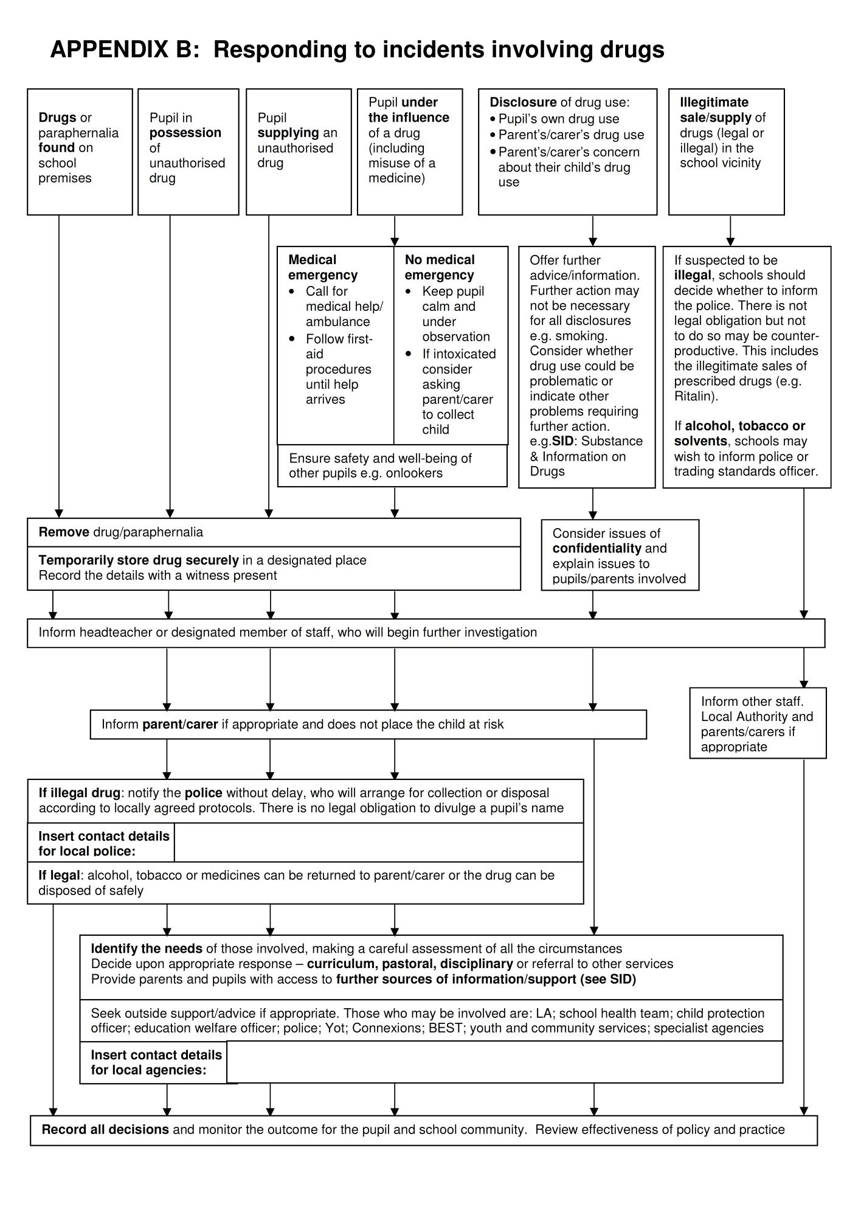age5image4118208928