English as an Additional Language (EAL) Policy
Manchester Vocational and Learning Academy

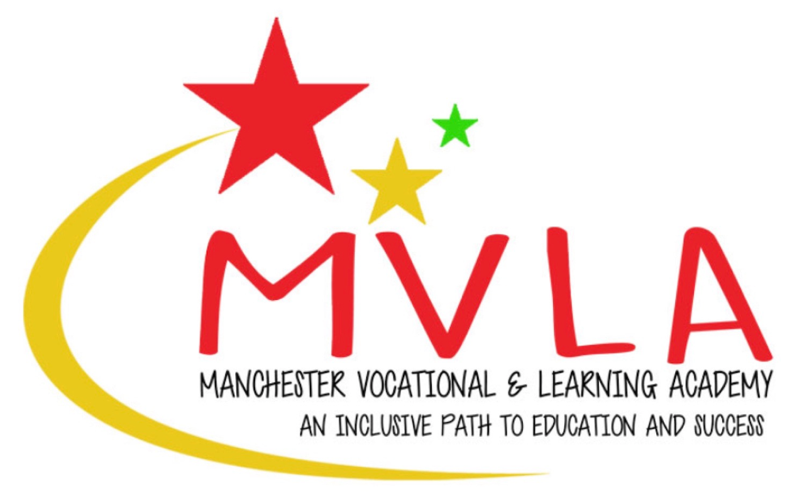

Approved by: | Linda Guest
Last reviewed on: | 1st September 2025
Next review due by: | September 2027

Manchester Vocational and Learning Academy is committed to safeguarding and promoting the welfare of children and expects all staff and volunteers to share this commitment. This policy is a statement of the aims, principles and strategies for the teaching and learning of English as an Additional Language (EAL).
What is EAL?
English as an Additional Language (EAL) includes both English as a second language and English as a foreign language – it is for pupils spending a short time in Britain, and for those who have settled here permanently. EAL is the study of English by students who already speak at least one other language or who come from a home in which a language other than English is used. Learning and communicating in our society is dependent on competence in English.
We are proactive in removing barriers that stand in the way of our EAL pupils learning and success. We do this by meeting our responsibilities to our EAL pupils ensuring they have equal access to the curriculum (and other educational opportunities) and the achievement of their educational potential and by providing our EAL pupils with a safe, welcoming, nurturing environment where they are accepted, valued and encouraged to participate. We promote the principles of fairness and justice for all through the education that we provide in our school ensuring EAL pupils receive opportunities for educational success that equals that of English speaking pupils.
Induction and Welcome to children with EAL.
The school will:
- Arrange a meeting with parents/carers to gather a range of information e.g. languages used in the home, previous schooling, and exposure to English. Where possible, invite an interpreter to attend if parents/carers do not speak English.
- Ask parents/carers or the referring school to bring in any reports, school text and exercise books from the pupil’s referring school.
- Give introductory information to parents/carers about the school including:
- Information about the English school system
- A plan of the school
- An outline of the school day.
- Calendar of term dates.
- Name of person to contact to get information about their child’s work and progress and if they have any concerns.
- Lunch arrangements and a sample lunch menu including information of benefits such as free school meals.
- (All of the above should be as visual as possible and translated if necessary/possible)
- Update staff who come into regular contact with the child with any specific information which may support teaching and learning.
- Establish a buddy system so that child has a ‘go to’ child for support.
The Nurture Group leader will assess each EAL pupil’s “proficiency level” using a new five-point scale (see box below). After the formal assessments have been completed, any new to English student who enters MVLA will be assessed on this five-point scale and given a proficiency level.
EAL pupil proficiency level 5-point scale
New to English | Early Acquisition | Developing Competence | Competent | Fluent
The pupil may:  Use first language for learning and other purposes  Remain completely silent in the classroom  Be copying/repeating some words or phrases  Understand some everyday expressions in English but may have minimal or no literacy in English  Needs a considerable amount of EAL support. | The pupil may:  Follow day-to-day social communication in English and participate in learning activities with support  Begin to use spoken English for social purposes  Understand simple instructions and can follow narrative/accounts with visual support  Have developed some skills in reading and writing  Have become familiar with some subject specific vocabulary  Still needs a significant amount of EAL support to access curriculum. | The pupil may:  Participate in learning activities with increasing independence  Be able to express self orally in English, but structural inaccuracies are still apparent  Be able to follow abstract concepts and more complex written English  Literacy will require ongoing support, particularly for understanding text and writing.  Requires ongoing EAL support to access curriculum fully. | Oral English developing well, enabling successful engagement in activities across the curriculum  Can read and understand a wide variety of texts  Written English may lack complexity and contain occasional evidence of errors in structure  Needs some support to access subtle nuances of meaning, to refine English usage, and to develop abstract vocabulary  Needs some/occasional EAL support to access complex curriculum material and tasks. | Can operate across the curriculum to a level of competence equivalent to a pupil who uses English as first language.  Operates without EAL support across the curriculum.
TEACHING AND LEARNING STYLE
In our school, teachers take actions to help children who are learning English as an Additional Language by various means. This include developing their spoken and written English by:
- Ensuring that vocabulary work covers the technical as well as the everyday meaning of key words, metaphors and idioms.
- Explaining how speaking and writing in English are structured for different purposes across a range of subjects.
- Providing a range of reading materials that highlight the different ways in which English is used.
- Ensuring that there are effective opportunities for talking and that talking is used to support writing
- Encouraging children to transfer their knowledge, skills and understanding of one language to another.
- Building on children's experiences of language at home and in the wider community, so that their developing uses of English and other languages support one another.
Ensuring access to the curriculum and to assessment by:

- Using accessible texts and materials that suit children's ages and levels of learning.
Providing support through ICT, video or audio materials, dictionaries and translators, visual support materials and readers.
- Using the home or first language where appropriate.
- Providing bilingual support to enable children to access the curriculum, learn basic classroom routines and to continue children's language development in their first language.
- Nurture Group support that allows children to work in smaller groups and increases opportunities for modelling language structures and for conversations between adults and children.
- Additional support to target groups of children who are operating at a level or more behind that which would be expected for their age/time in school.
ROLES AND RESPONSIBILITIES
All staff have a responsibility for supporting and encouraging children to become fluent English speakers and for communicating school expectations for writing, speaking and listening.
All staff have responsibility for:
- Modelling good use of English, in extending sentences and encouraging children to do the same.
- Communicating to students that they are expected to speak clearly and audibly using more than single words as appropriate.
- Communicating to students that they are expected to listen and respond when someone speaks to them.
All teachers have responsibility for:
- Planning work in the context of children's stage of fluency and anticipating opportunities for developing use of English
- Planning a clearly identified language focus for each lesson which will aid second language acquisition and is made explicit to the pupils.
- Setting targets for improving oracy, speaking and listening and writing. - Assessing and tracking progress in writing and speaking and listening.
This policy will be reviewed by the Headteacher every two years.

