Lunch Policy
Manchester Vocational and Learning Academy

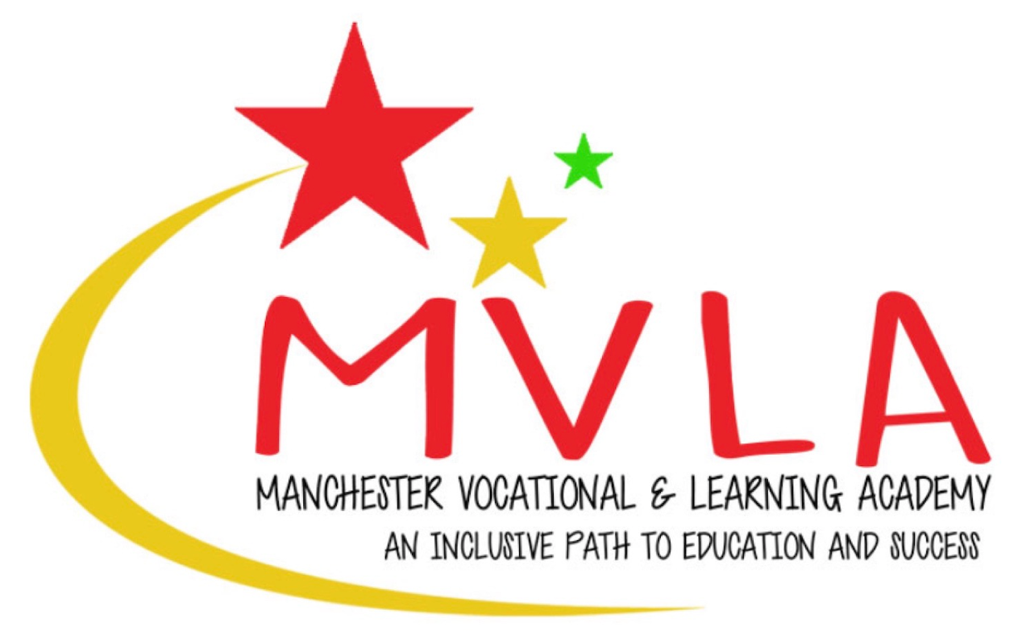

Approved by: | Linda Guest
Last reviewed on: | 1st September 2025
Next review due by: | September 2027

At Manchester Vocational and Learning Academy, we provide a daily lunch for our students. This policy sets out the procedures and rules surrounding the provision of lunches on our premises.

Provision of meals

All students will be provided with a daily lunch during term time. This will be free of charge, regardless of the individual student’s Free School Meals eligibility.

The lunch provided will be from a local supermarket or caterer that has been quality assured by the school leadership team and is known to meet the relevant food safety and hygiene standards.

All students present at the beginning of the day will be given a meal at lunchtime. Lunch will never be withdrawn as a sanction.

Student Choice

Students will be given a range of choices, including vegetarian and Halal options. The caterers used by the school will provide a reasonable number of options each day in order to satisfy a wide range of tastes and preferences.

Students will not be forced to order a lunch if they do not wish to do so, nor will they be forced to eat any food provided. However, we do not have the resource to offer additional choices beyond those provided by our designated caterer. If a student decides to decline the offer of a lunch we will not be able to offer alternatives.

Packed lunches
If a student wishes to do so, they can bring their own packed lunch which will be stored in the designated student fridge in the school kitchen. This should be food which requires no preparation as the school does not have the facilities to facilitate this.

Students will not be permitted to make hot drinks or prepare food in the oven or microwave due to safety considerations. Staff will not be permitted to do this for them as this is not part of their role.

Students should not share food that they have brought onto the premises with other students, as there might be health considerations. Students who breech this rule may be given a sanction in accordance with our Behaviour Policy.

Reward meals
In some circumstances (for example during Rewards time on a Friday) a special meal will be provided from an alternative caterer. This caterer will have been quality assured by senior leaders and will be known to meet the relevant food safety and hygiene standards.

Rewards meals are a privilege and not a right. However, if the student is not eligible for a reward meal they will be offered an alternative from the school’s usual caterer or the supermarket.

Specific dietary needs
Parents/carers will be asked about specific dietary needs during the pre-admission process. Every attempt will be made to cater for students with specific dietary requirements. In the unlikely event of this not being possible, parents/carers will be asked to provide a packed lunch.

Late arrival
Lunch orders needs to be placed by 11 am each day, in order for the food to be prepared or purchased. If students arrive in school after this time, attempts will be made to provide a lunch, but this cannot be guaranteed unless the parent/carer has been in touch prior to 11 am and booked a lunch in advance. Students arriving after 11 am without a pre-booked lunch are encouraged to bring a packed lunch.

