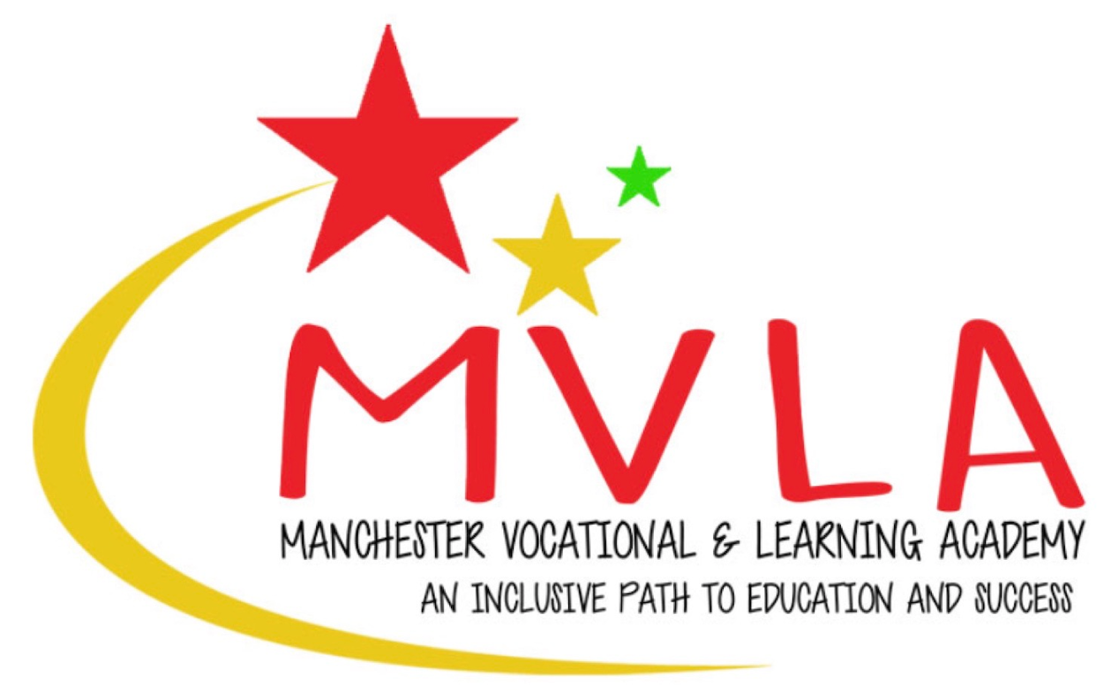

**Staff Dress Code**

**Manchester Vocational and Learning Academy**

**September 2024**

**Contents**

1. Introduction 3

2. Scope and purpose 3

3. Your appearance 3

4. Religious or cultural dress 5

5. Implementing and reviewing our dress code 5

6. Review of policy 5

Introduction

## We require our employees to maintain an appropriate professional standard of dress and personal appearance at work and when representing Manchester Vocational and Learning Academy. The purpose of our dress code is to establish basic guidelines to help employees understand the required standards of dress and appearance so that we:

### promote a positive image to our students and employees look professional;

### respect religious, racial and cultural requirements;

### ensure that all genders are treated equally

### make any adjustments that may be needed because of disability where possible;

### take account of health, safety and security requirements; and

### guide employees to make appropriate choices of what to wear to work.

## The overriding principle of our policy is that our employees dress in a manner appropriate to their working environment and the type of work they do in the School.

## The policy is not exhaustive in defining acceptable and unacceptable standards of dress and appearance, and employees must use common sense in adhering to the principles underpinning the policy. The senior leadership team of the school will be the sole judge of what is and is not appropriate for the purposes of this policy.

## We recognise the diversity of cultures and religions of our employees and will take a sensitive approach when this affects dress and uniform requirements, priority will be given to health and safety, security and other similar considerations.

## Any enquiries regarding the operation of our dress code (including whether an article of clothing is suitable to wear to work) should be made to the Headteacher/Proprietor.

## This policy does not form part of any employee's contract of employment and may be amended at any time. Any breach of this policy may result in disciplinary action being taken.

Scope and purpose

## This policy covers all employees of Manchester Vocational and Learning Academy. In addition, members of the management committee, volunteers and other workers (including ITT and supply teachers) will be made aware of the policy so that they can make appropriate decisions regarding dress and appearance whilst at the school.

Appearance

## While working for us, employees represent us with our students, parents and visitors to Manchester Vocational and Learning Academy. Employee appearance contributes to our reputation and our commitment to delivering excellent teaching and learning. Employee dress and appearance should be appropriate to the role performed in the school.

## All members of staff are supplied with an identity badge that must be worn and visible at all times when at work. If staff lose or misplace this they must notify the Proprietor

## It is important that employees appear clean and smart at all times when at work. Employees are expected to demonstrate good standards of personal hygiene.

## Employees must wear smart, business attire appropriate to the circumstances.

## Employees who are involved in sports activities may dress in appropriate sports clothing for PE or dance lessons and other related activities. They may remain in this clothing when teaching in the classroom.

## Clothing should not be dirty, frayed or torn. Tops should not carry wording or pictures that might be offensive or cause damage to our reputation. The following should not be worn whilst at work/representing Manchester Vocational and Learning Academy:

### beach wear (For example but not exclusively- vests, flip flops)

### track suits (unless teaching PE or other related activities)

### casual or sports t-shirts

### combat trousers

### jogging bottoms

### dungarees

### casual denim (smart sold coloured denim is permitted at the Headteacher/Proprietors discretion

### very short miniskirts/dresses (dresses and skirts should be no more than 5cm above the knee)

### low cut t-shirts, blouses or transparent clothing

### shorts (unless teaching PE or other related activities)

## Footwear must be safe and clean and take account of health and safety considerations. Trainers (unless teaching PE or other related activities), backless shoes and flip-flops are not acceptable.

## Where we provide safety clothing and equipment, including protective footwear, it should be worn or used as appropriate and directed.

## Employees should not wear clothing or jewellery that could present a health and safety risk. Any jewellery should not be excessive or unconventional. Earrings must not be obtrusive or ostentatious.

## Employees may be asked to cover up visible tattoos.

## Employees who occupy roles that require protective clothing, e.g. hard hats, masks and gloves, are required to wear this clothing while carrying out their duties whenever required by law or by the school's rules.

## In addition, any employee whose job involves working with machinery/working with food must keep their hair either short or tied back and must not wear any jewellery other than a wedding ring. These rules are in place for safety/hygiene reasons.

## In all roles, hair should be neat, tidy and well groomed. Unconventional styles and colours are not acceptable.

Religious or cultural dress

## Employees may wear religious and cultural dress (including head scarves, skullcaps and turbans) unless it breaches this policy or compromises the health and safety of the wearer, their colleagues or any other person.

## Where necessary your line manager can disseminate appropriate information explaining cultural dress and customs.

## Priority is at all times given to health and safety requirements.

Implementing and reviewing our dress code

## The Headteacher and line managers are responsible for ensuring that employees observe the standards set by this dress code.

## Failure to comply with the dress code may result in action under our Disciplinary Procedure.

## We will review the dress code periodically to ensure that it meets our demands, in particular with regard to health and safety of our Employees and all those they deal with.

Review of policy

## This policy is reviewed regularly by the management committee. We will monitor the application and outcomes of this policy to ensure it is working effectively.