Manchester Vocational and Learning Academy

Reference Policy Statement

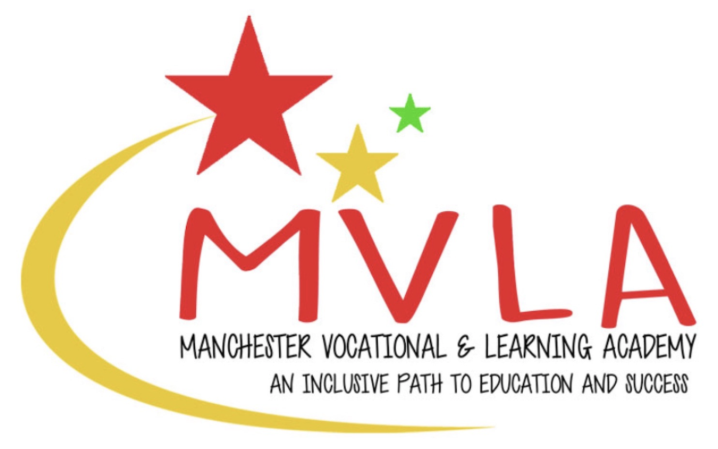

|  |  |  |
| --- | --- | --- |
| **Approved by:** | The Management Committee |  |
| **Last reviewed on:** | 1st September 2024 | |
| **Next review due by:** | September 2026 | |

It is the policy of Manchester Vocational and Learning Academy (MVLA) to only provide prospective employers with references regarding former employees who have worked for the company within the past three years. However, if the employee worked for MVLA more than three years ago, but was their last employer we will provide basic information to allow a prospective employer to progress with a possible appointment.

For employees who have worked at MVLA within the past three years we will provide prospective employers with the dates of employment, final job title and the final salary of a former employee. Where requested we will also provide information about our opinion on their suitability to work with children and whether there was any disciplinary action on their record. References will be provided by the Headteacher/Proprietor only.

The needs, requirements and expectations of employers vary considerably. Therefore, if employees wish to assess the suitability of any former employee of the school, they should do so through their own recruitment procedures.

This policy statement will be reviewed by the Management Committee every 2 years.