Manchester Vocational and Learning Academy

Reference Policy Statement

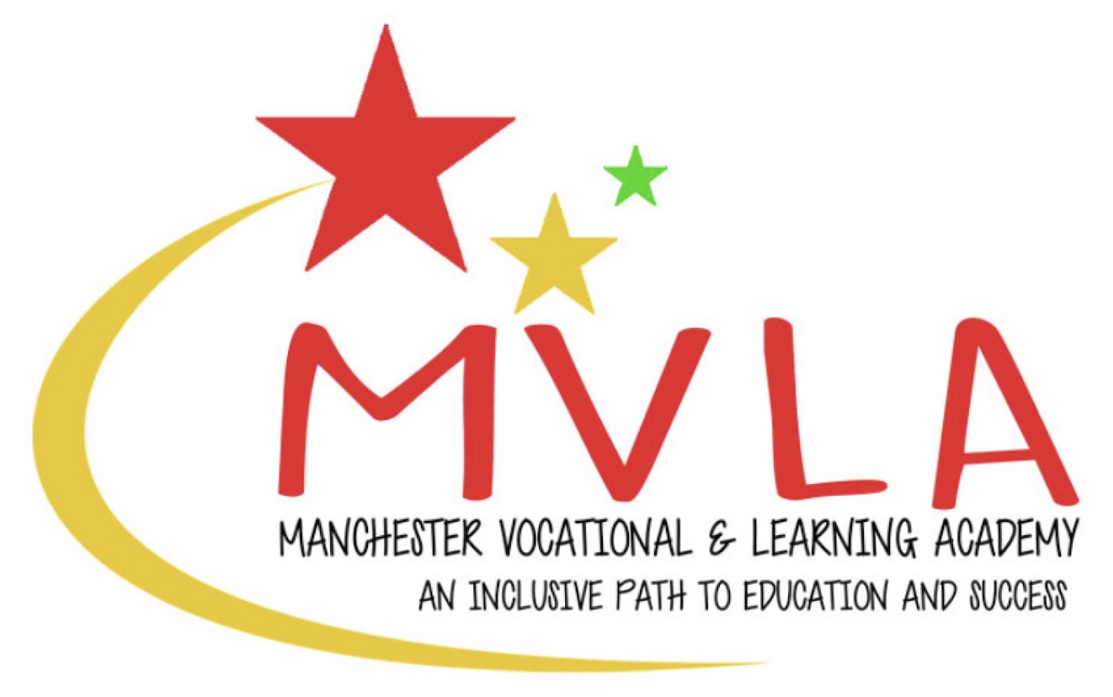

Approved by: | The Management Committee
Last reviewed on: | 1st September 2025
Next review due by: | September 2027

It is the policy of Manchester Vocational and Learning Academy (MVLA) to only provide prospective employers with references regarding former employees who have worked for the company within the past three years. However, if the employee worked for MVLA more than three years ago and MVLA was their last employer we will provide basic information to allow a prospective employer to progress with a possible appointment.

For candidates who have worked at MVLA within the past three years we will provide prospective employers with the dates of employment, final job title and the final salary of a former employee. For relevant positions we will also provide information regarding whether there were any safeguarding concerns. References will be provided by the Headteacher/Proprietor only.

The needs, requirements and expectations of employers vary considerably. Therefore, if employees wish to assess the suitability of any former employee of the school, they should do so through their own recruitment procedures.

This policy statement will be reviewed by the Management Committee every 2 years.

