SMSC Policy
Manchester Vocational and Learning Academy

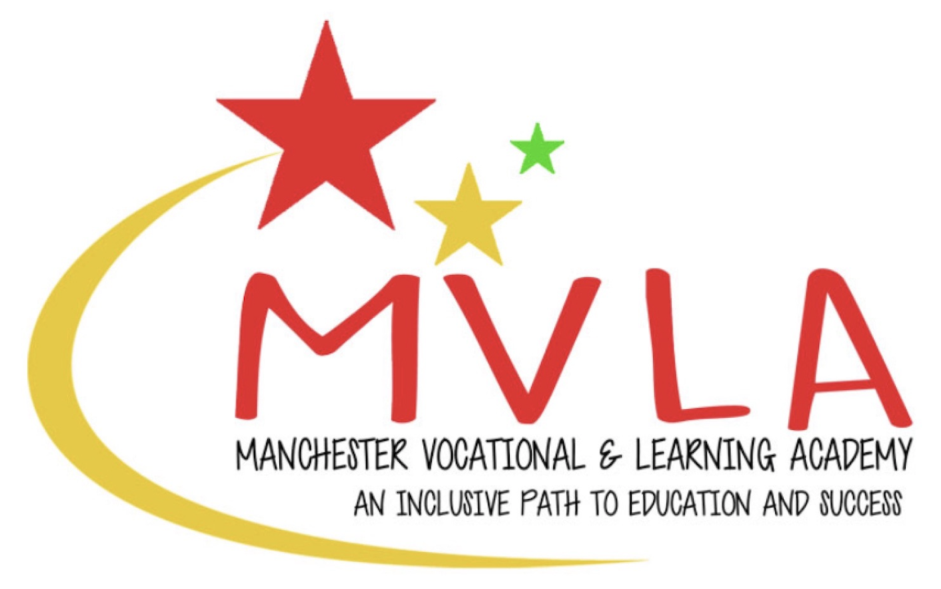

Approved by: | Linda Guest
Last reviewed on: | 1st September 2024
Next review due by: | September 2026

Policy statement
The vision of the Manchester Vocational and Learning Academy is to provide an education that prepares its students for life in modern day Britain.

We aim for all students to:
- achieve their potential through a culture of high academic, personal and social expectations and aspirations;
- have their needs met and be recognised as individuals through high quality inclusion and pastoral care systems;
- learn in a safe, healthy and stimulating environment in which every child matters and in which parents / carers and the wider community are part of the learning journey;
- enjoy an all-round education beyond academic study, so that each can discover his or
- her latent talents.

Through this vision we intend for our young people to be equipped to take their place in society as valued, economically viable and responsible citizens. Our students will leave Manchester Vocational and Learning Academy empowered as independent, co-operative, innovative and motivated young adults with the skills for and love of learning for life.

The importance of students’ SMSC development is widely recognised and an integral part of the current Ofsted framework, and plays an essential and significant part in students’ education. Activities at Manchester Vocational and Learning Academy are consciously planned to contribute to students’ SMSC development, such as in assemblies, acts of worship, curriculum programmes and lessons in PSHE, citizenship and life skills. Contributions to the SMSC programme can be found across the entire curriculum, enrichment programme and in extra-curricular activities.

Spiritual development of students
‘Spiritual’ is not synonymous with ‘religious’ but Manchester Vocational and Learning Academy recognises that some students will express their spiritual awareness in religious terms.

We foster students’ spirituality by encouraging the following:

- giving students the opportunity to explore values and beliefs including religious beliefs and the way in which they affect people’s lives;
- enabling students to develop a set of values, principles and beliefs;
- encouraging students to explore and develop what animates and inspires themselves and others;
- encouraging students to express innermost thought and feelings through, for example art, music, literature and crafts, exercising the imagination, inspiration, intuition and insight;
- promoting teaching styles which:
- value students’ questions and give them space for their own thoughts ideas and concerns;
- enable students to make connections between aspects of their learning;
- encourage students to relate their learning to a wider frame of reference;
- encourage students to consider and respect a diversity of opinions.

Moral development of students
Moral development is about students building a framework of moral values which regulates their personal behaviour, developing an understanding of society’s shared and agreed values. Students at Manchester Vocational and Learning Academy who are becoming morally aware are likely to be developing some or all of the following characteristics:
• an ability to distinguish right from wrong;
• an ability to think through the consequences of their own and others actions;
• a willingness to express their views on ethical issues and personal values;
• a respect for others’ needs, interests and feelings as well as their own;
• participation in charity fundraising or other such behaviour.

Manchester Vocational and Learning Academy encourages the students’ moral behaviour development through the Behaviour Policy, for example the 6Cs to Success and the use of restorative justice.

Social development of students
Social development ensures students can adjust appropriately and sensitively to a range of social contexts and experiences. Our expectation for students at Manchester Vocational and Learning Academy is that they are able to relate well to their peers and adults.

Manchester Vocational and Learning Academy will foster students’ social development by:
- encouraging students to work and learn co-operatively;
- encouraging students to develop their skills of empathy and tolerance;
- encouraging students to recognise and respect differences and similarities;
- providing opportunities for students to exercise and responsibility across year groups and the school;
- providing positive and effective links with the world of work and the wider community;
- encouraging inter-generational links and work
.
Cultural development of students
Manchester Vocational and Learning Academy will encourage students’ cultural development by:
- providing opportunities for students to explore their own cultural values;
- addressing discrimination on the grounds of race, religion, gender, sexual orientation, age and other criteria and promoting racial and other forms of equality;
- recognising and nurturing particular abilities, gifts and talents;
- providing opportunities for students to participate in cultural events;
- developing partnerships with outside agencies and individuals to extend students’ cultural awareness and awareness of diversity.

Promoting SMSC across Manchester Vocational and Learning Academy
We promote SMSC through:
- assemblies and collective acts of worship (which are sometimes held as daily discussions)
- the Citizenship) curriculum;
- philosophy and ethics debates:
- curricular activities and events;
- maintaining positive relationships with parents / carers and the wider community;
- the learning and teaching environment;
- inclusion;
- displays;
- fundraising for charity;
- Student leadership opportunities:
- a wide range of visits and visitors;
- the induction and transition procedures for students;
- various aspects of our enrichment and extra-curricular programmes.
- This list is indicative not exhaustive.

British Values
In the document “Promoting fundamental British values as part of SMSC in schools: Departmental advice for maintained schools - November 2014” the DfE state:
“Schools should promote the fundamental British values of democracy, the rule of law, individual liberty, and mutual respect and tolerance of those with different faiths and beliefs1. This can help schools to demonstrate how they are meeting the requirements of section 78 of the Education Act 2002, in their provision of SMSC.

Actively promoting the values means challenging opinions or behaviours in school that are contrary to fundamental British values. Attempts to promote systems that undermine fundamental British values would be completely at odds with schools’ duty to provide SMSC. The Teachers’ Standards expect teachers to uphold public trust in the profession and maintain high standards of ethics and behaviour, within and outside school. This includes not undermining fundamental British values.”

Through our SMSC Policy, Manchester Vocational and Learning Academy aims to:
- enable students to develop their self-knowledge, self-esteem and self-confidence;
- enable students to distinguish right from wrong and to respect the civil and criminal
- law of England;
- encourage students to accept responsibility for their behaviour, show initiative, and
- to understand how they can contribute positively to the lives of those living and
- working in the locality of the school and to society more widely;
- enable students to acquire a broad general knowledge of and respect for public
- institutions and services in England;
- further tolerance and harmony between different cultural traditions by enabling
- students to acquire an appreciation of and respect for their own and other cultures;
- encourage respect for other people; and
- encourage respect for democracy and support for participation in the democratic
- processes, including respect for the basis on which the law is made and applied in England.

The list below describes the understanding and knowledge expected of students as a result of schools promoting fundamental British values:
- an understanding of how citizens can influence decision-making through the democratic process;
- an appreciation that living under the rule of law protects individual citizens and is essential for their wellbeing and safety;
- an understanding that there is a separation of power between the executive and the judiciary, and that while some public bodies such as the police and the army can be held to account through Parliament, others such as the courts maintain independence;
- an understanding that the freedom to choose and hold other faiths and beliefs is protected in law;
- an acceptance that other people having different faiths or beliefs to oneself (or having none) should be accepted and tolerated, and should not be the cause of prejudicial or discriminatory behaviour; and
- an understanding of the importance of identifying and combatting discrimination.

Complaints
Any complaints about this should be made in accordance with the school’s Complaints Policy. Any other complaints should be brought to the attention of the Headteacher in the first instance.

Complaints that are in the public interest and relate to suspected malpractice may be appropriate to raise under the school’s Whistleblowing Policy.

Compliance and performance monitoring
The Management Committee will review this policy every two years and ensure that practice across all schools is in line with this policy. Any review will take into account the most up-to-date legislation and SMSC expectations from Ofsted.

