PARENT FACTSHEET – JANUARY 2022
10 tips to stay safe online
Not sure what advice to give your child? Our pointers have got you covered.
- Be careful about talking to people you don’t know and trust in real life – anyone can pretend to be a child online. If you do talk to people you don’t know, don’t give away personal information – such as what street you live on or where you go to school, or share your location with them. Say no to any requests they send you for images or videos of yourself, and stop talking to them
- Set your profiles to private, to limit what others can see
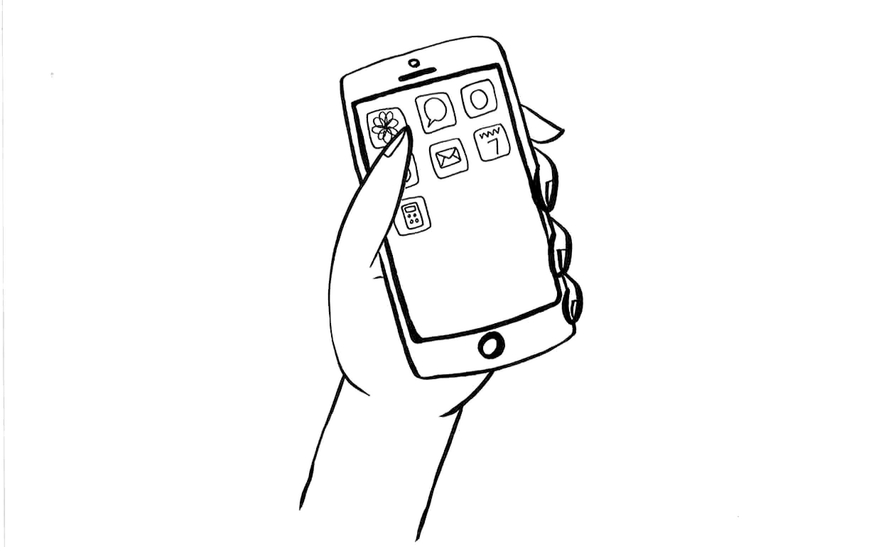
- Think carefully about what you share and with who. Once you’ve shared an image, you’ve no control over what the other person does with it. Remember, it’s illegal to take, share or view sexual images of under-18s, full stop
- Be mindful of your digital footprint. What you post online now could come back to bite you later, like when applying for jobs, college or university
- If you see something upsetting, or someone bullies you, tell an adult you trust. Report it too
- When reading news online, ask yourself what the source is, when it was published, and whether it could be a hoax or made up. Read beyond the headline too
- Remember, people try to make their lives look more exciting and interesting online. There’s a lot people can do with photo editing to make their photos look better. So don’t assume everything you see is a true-to-life representation
- Watch out for hoaxes and scams, like messages you’re meant to forward on or that ask you for payment details or your password
- Take any content that seems to glamourise gang lifestyles with a very large pinch of salt – it’s not as glamourous as it looks. Be wary of schemes promising easy cash for receiving and transferring money too, they’re almost definitely criminal activity
- Watch out for loot boxes or other parts of games where you pay money to take a chance on getting a reward – you can get sucked into spending lots of money on them
Don’t feel confident starting a conversation with your child about what they’re up to online? Read this advice from the NSPCC: https://www.nspcc.org.uk/keeping-children-safe/online-safety/talking-child-online-safety
Further information
This factsheet was produced by Safeguarding Training Centre from The Key: www.thekeysupport.com/safeguarding
- ‘Ban kids from loot box gambling in games’, BBC News, 12 September 2019
https://www.bbc.co.uk/news/technology-49661870
- How to spot fake news, Childline
https://www.childline.org.uk/get-involved/articles/how-to-spot-fake-news/
- ‘Rescue and Reponse county lines project: strategic assessment 2019, Greater London Authority
https://www.london.gov.uk/mopac-publications/rescue-and-response-pan-london-county-lines-service
- Home, Money Mules
https://moneymules.co.uk/
- Sharing nudes and semi-nudes: advice for education settings working with children and young people, GOV.UK – Department for Digital, Culture, Media and Sport, UK Council for Internet Safety
https://www.gov.uk/government/publications/sexting-in-schools-and-colleges

